Pros and cons of Windows 8
Cons:
- Lack of standard folders.
- It’s impossible to roll up the windows or miniaturize them.
- Instead of up and down scrolling you have from side to side one.
- Lack of definite classification of icons.
- Lack of the “Start” button. However, there’s analogue of this button which is delivered by function of “hot corners”. You should bring a cursor in left lower corner and click once. The problem is that if you budge the mouse, start screen disappears.
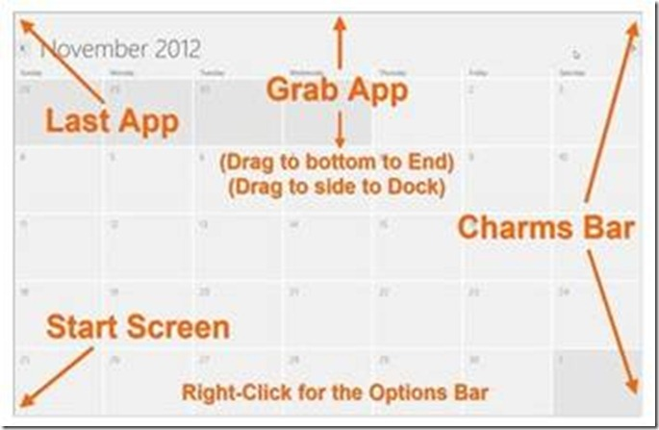
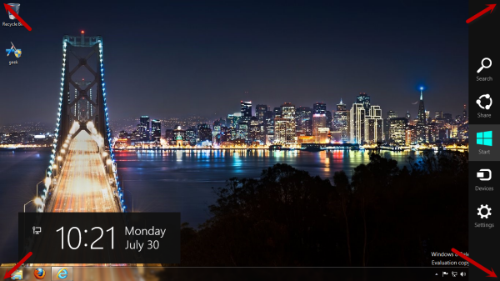
- Interface is quite uncomfortable for users who have laptops or other devices that demand a mouse.
- Lack of “cross” in the corner of the window. If you want to close the window or an app, you should pass from upper to the bottom edge or run down the cursor from the top edge. Luckily, combination ALT+F4 is still available, so you can use it.
Pros:
- The OS works faster and download is also very quick.
- It’s quite comfortable for graphic pad users. The OS interacts with smartphones and graphic pads. Wonderful integration with different platforms.
- Good browser. The Explorer 10 is really noteworthy. Although there’s no bookmark toolbar, it’s excellently designed and has large icons.
- There’s a host of new useful innovations that are connected with copying and pasting of files. They are combined in a single window which allows the users to control the copy tasks, change its order, stop or cancel the process.

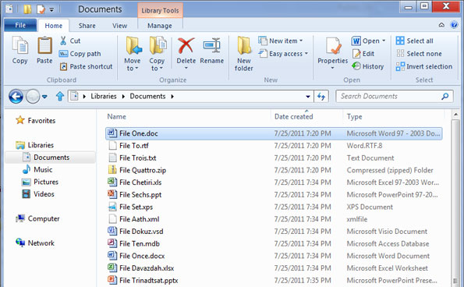

- Installation is the same as it was in Windows 7. New OS doesn’t demand any special resources. All you need is a processor with frequency of 1 GHz, 2 GB of on-line storage and 16 GB on the hard disk.
- One more advantage of Windows 8 consists in enhanced safety, antivirus software is improved.
- Nice design.
- Ameliorated file storage with the help of SkyDrive. New system allows work with virtual disks and remote computers or networks. Also, computer proposes you to save the information using the on-line service.

